Grade 9 - Term 2: The Nuclear Age and the Cold War

Section A
Increasing tension between the Allies after the end of World War II in Europe
Although relations between the Soviet Union and the United States had been strained in the years before World War II, the U.S.-Soviet alliance of 1941–1945 was marked by a great degree of cooperation and was essential to securing the defeat of Nazi Germany. As late as 1939, it seemed highly improbable that the United States and the Soviet Union would forge an alliance. U.S.-Soviet relations had soured significantly following Stalin’s decision to sign a non-aggression pact with Nazi Germany in August of 1939. In spite of intense pressure to sever relations with the Soviet Union, Roosevelt never lost sight of the fact that Nazi Germany, not the Soviet Union, posed the greatest threat to world peace. In order to defeat that threat, Roosevelt confided that he “would hold hands with the devil” if necessary.
Finally, two devastating atomic bomb attacks against Japan by the United States, coupled with the Soviets’ decision to break their neutrality pact with Japan by invading Manchuria, finally led to the end of the war in the Pacific. Soon after the war, the alliance between the United States and the Soviet Union began to unravel as the two nations faced complex post- war decisions.
USSR (communism) vs. USA and West (capitalism)
No rivalry between different nations had greater implications for the entire world than that between the United States and the Soviet Union in the second half of the 20th century. Separated by vastly different political, economic, and social philosophies, tensions between the Soviet Union and the United States, a period historians term the Cold War, had the potential to lead to the end of the world as we know it.
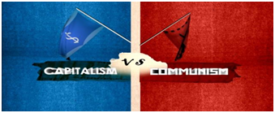USSR (communism) vs. USA and West (capitalism).
At various conferences, the most important of which were at Yalta and Potsdam, the three powers split Germany and its capital Berlin in two, with the eastern portion controlled by the Soviet Union and the western portion controlled jointly by the United States, the United Kingdom, and France. Additionally, the Soviet Union was given influence over the governments of several Eastern European states, where they promptly set up loyal, communist puppet regimes.
The United States and the West feared the creation of this Eastern Bloc, as Western journalists and government termed it, and the further spread of communism and/or totalitarian states in the rest of the world. U.S. foreign policy became one of containment - essentially, stopping the spread of communism wherever it could. This was in direct opposition to the Soviet Union's policy of fostering the spread of communism, especially in its Asian neighbours. The Americans then feared that the USSR/ Communist influence that already spread over Eastern Europe, would influence the democracies of Western Europe.
Definition of the superpowers and the meaning of ‘Cold War’
The concept of a superpower was a product of the Cold War and the nuclear age. Its common usage only dates from the time when the adversarial relationship of the United States and the Soviet Union became defined by their possession of nuclear arsenals that were so formidable that the two nations were set apart from any others in the world. Superpower diplomacy is thus closely related to nuclear weapons. A superpower is defined as a state that has a leading position in the international system, capable of projecting significant military power anywhere in the world. In 1944, when the term was coined, there were three superpowers: the United States, the British Empire, and the Soviet Union. Throughout the time known as the Cold War, the rivalry between the superpowers the US and the USSR, set the tenor for world politics after Great Britain fell from its place as a superpower due to the stresses of the war and numerous independence movements among its colonies. Today the USA is seen as the only remaining superpower after the fall of the Soviet Union in 1991.
The Cold War refers to the nonviolent conflict between the U.S. and the former U.S.S.R. after 1945. In other words, it was the conflict or dispute between two groups (USA and USSR) that does not involve actual physical fighting.
Questions
- Define the following terms:
- Communism
- Capitalism
- Cold War
- Superpower
- What was the Eastern Bloc?
- Why was the USA afraid of the spread of communism?

Section B
Areas of conflict and competition between the Superpowers in the Cold War
Arms race
An arms race denotes a rapid increase in the quantity or quality of instruments of military power by rival states in peacetime; in this case, the rivalry between the USA and USSR after the Second World War. The build- up of arms is one of the most profound characteristics of the Cold war. The Arms race started with the creation of ‘Trinity’- the first bomb tested in New Mexico by the USA in 1945 On August 29th, 1949, the Soviet Union detonated its first atomic bomb, at the Semipalatinsk Test Site in Kazakhstan. This event ends America's monopoly of atomic weaponry and launches the Cold War. In the 1950's, The Arms Race became the focus of the Cold War. America tested the first Hydrogen (or thermo-nuclear) bomb in 1952, beating the Russians in the creation of the "Super Bomb".
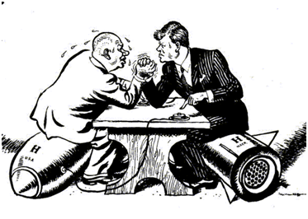A cartoon showing the two presidents of the opposing countries involved in the Cold War. Image source
The political climate of the Cold war became more defined in January, 1954, when U.S. Secretary of State John Foster Dulles announced the policy that came to be known as "massive retaliation" -- any major Soviet attack would be met with a massive nuclear response. As a result to the challenge of "massive retaliation" came the most significant by-product of the Cold War, the Intercontinental Ballistic Missile (ICBM), which were supported with the thermo-nuclear bomb (with a much greater destructive power than the original atomic bomb), inertial guidance systems (defines the difference between weight, the influence of gravity and the impact of inertia), and powerful booster engines for multistage rockets. For more than thirty years, the ICBM has been the symbol of the United States' strategic nuclear arsenal.
In October 1961, The Soviet Union detonates a nuclear device, estimated at 58 megatons, the equivalent of more than 50 million tons of TNT, or more than all the explosives used during World War II. It is the largest nuclear weapon the world had ever seen at that time. The Tsar Bomba (King of the Bombs) is detonated after US and USSR agrees to limit nuclear testing. It is the largest nuclear device ever exploded. Having no strategic military value, Tsar is viewed as an act of intimidation by the Soviets.
Space race
The Space Race was exacerbated by events such as the construction of the Berlin Wall, the Cuban Missile Crisis and the outbreak of war n Southeast Asia. On October 4, 1957, a Soviet R-7 intercontinental ballistic missile launched Sputnik (Russian for “traveler”), the world’s first artificial satellite and the first man-made object to be placed into the Earth’s orbit, which came as a surprise to Americans. They had seen space exploration as the next frontier; a logical extension of the grand American tradition of exploration, and it was crucial not to lose too much ground to the Soviets. In 1958, the U.S. launched its own satellite, Explorer I, designed by the U.S. Army under the direction of rocket scientist Wernher von Braun. That same year, President Dwight Eisenhower signed a public order creating the National Aeronautics and Space Administration (NASA), a federal agency dedicated to space exploration.
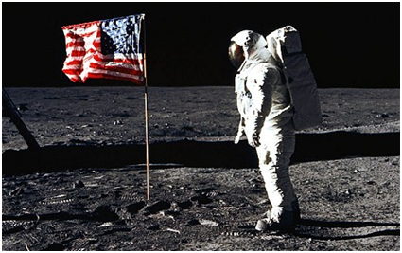Buzz Aldrin poses for a photograph beside the U.S. flag during the Apollo 11 mission on July 20, 1969. Image source
In 1959, the Soviet space program took another step forward with the launch of Luna 2, the first space probe to hit the moon. In April 1961, the Soviet cosmonaut Yuri Gagarin became the first person to orbit Earth, traveling in the capsule-like spacecraft Vostok 1. For the U.S. effort to send a man into space, dubbed Project Mercury, NASA engineers designed a smaller, cone-shaped capsule far lighter than Vostok, and on May 5, astronaut Alan Shepard became the first American in space (though not in orbit). The USA stated that they would be able to launch the first man in space.
By landing on the moon, the United States effectively “won” the space race that had begun with Sputnik’s launch in 1957. The American public’s attention was captivated by the space race, and the various developments by the Soviet and U.S. space programs were heavily covered in the national media. While American astronauts were depicted as heroes, Soviets were pictured as the ultimate villains, with their massive, relentless efforts to surpass America and prove the power of the communist system.

Questions (Section B)
- What was the nature of the Arms race between the USSR and the USA?
- What do you think both sides wanted to achieve in the arms race?
- Why did the USA and USSR compete in space?
- How did the USA win the space race?

Section C
The Berlin wall
As they had agreed at Yalta and Potsdam, Germany was divided into four zones of occupation. At first relations between the forces were good as all were united in the belief that Nazism should be crushed. However, the USA, Britain and France saw quickly that Germany would have to be supported economically if communism was to be prevented. The allies wanted a strong, democratic country to become their ally, who acted as a buffer against the communist states of Eastern Europe. In contrast, Stalin wanted to weaken Germany as a punishment for the war, to help rebuild the USSR by stealing German industrial technology and to make communism seem more attractive to the Germans. The West depended upon Soviet goodwill to keep open routes to the British, French and American zones of the city.
During 1961, in an effort to stem the tide of refugees attempting to leave East Berlin, the communist government of East Germany begins building the Berlin Wall to divide East and West Berlin. Construction of the wall caused a short-term crisis in U.S.-Soviet bloc relations, and the wall itself came to symbolize the Cold War.
Throughout the 1950s and into the early 1960s, thousands of people from East Berlin crossed over into West Berlin to reunite with families and escape communist repression. To put an end to this outflow of people, all entry points in to West Berlin were blocked and the wall successfully pided the two parts of Berlin.
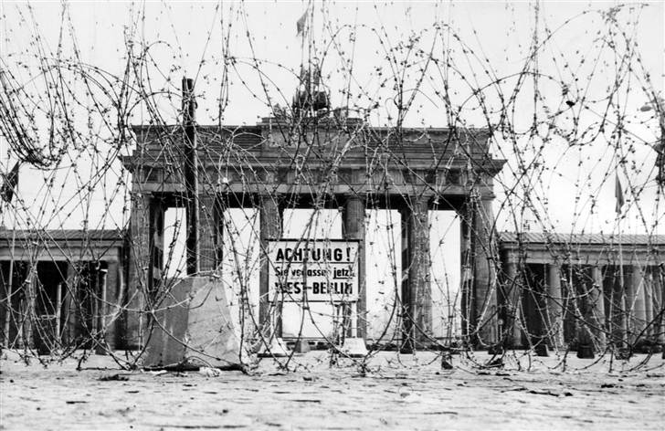
The Berlin Wall was erected to separate East and West Berlin following the wider partition of Germany after the Second World War. Image source

The fall of the Berlin Wall 1989
The Berlin Wall came to be the symbol of the Cold War division in Europe. This wall symbolised the difference between the western democrats and the eastern communists and the way they thought Germany should be lead. It also symbolised the inner conflict of Germany and the division between ‘free’ or democratic. On 9 November 1989, the communist authorities of the German Democratic Republic had announced the removal of travel restrictions to democratic West Berlin. Thousands of East Germans streamed into the West, and in the course of the night, celebrants on both sides of the wall began to tear it down.
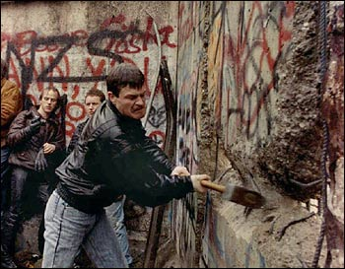
A German resident breaking down the Berlin Wall. Image source
For two generations, the Wall was the physical representation of the Iron Curtain, and East German border guards had standing shoot-to-kill orders against those who tried to escape. But just as the Wall had come to represent the pision of Europe, its fall came to represent the end of the Cold War. Throughout the Soviet bloc, reformers assumed power and ended more than 40 years of dictatorial communist rule. The reform movement that ended communism in east central Europe began in Poland. Two years later, the 15 communist satellite states that formed art of the USSR separated and collapsed like dominoes. By 1990, former communist leaders were ousted from their positions and free elections were held.
Mikhail Gorbachev played a pivotal role in the events leading up to the wall's demise and beyond. His policies of “perestroika” - economic restructuring - and “glasnost,” or openness, which eliminated traces of Stalinist repression, like the banning of books and the omnipresent secret police, and gave new freedoms to Soviet citizens, paved the way for the dissolution of communist power in Eastern Europe and ultimately led to the collapse of the Soviet Union.
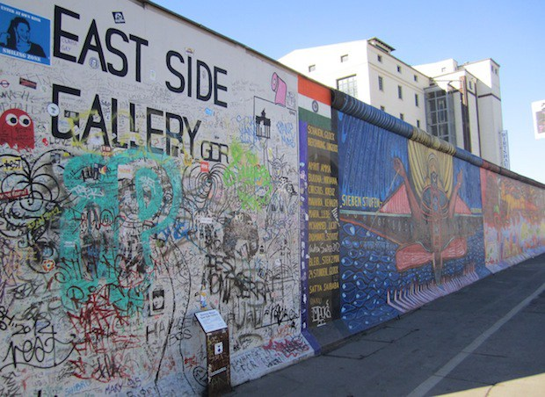The East Side Gallery, which is a 1.3 kilometer section of the Berlin Wall. Image source
The reunification of East and West Germany was made official on October 3, 1990, almost one year after the fall of the Berlin Wall.

Source: https://www.sahistory.org.za/article/grade-9-term-2-nuclear-age-and-cold-war
Questions (Section C)
- How was Germany divided after World War 2?
- Why was Germany split into two countries during the Cold War?
- Why was the Berlin wall built?
- What signalled the end of the Cold war?

